**P615/1**

**ART**

**Paper 1**

**Jul/Aug 2016**

3 hours

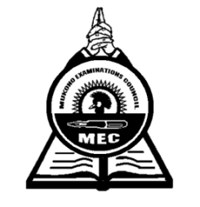

**MUKONO EXAMINATIONS COUNCIL**

**Uganda Advanced Certificate of Education**

**ART**

DRAWING OR PAINTING FROM NATURE AND STILL LIFE

Paper 1

3 hours

**Note:***Candidates must be instructed that* ***ruling*** *by all means whatsoever is* ***forbidden*** *except when marking off space for name and other particulars.*

This paper offers two major alternatives A and B. Candidates may attempt either A or B but not both

**ALTERNATIVE A:** Drawing or painting from Nature.

Candidates are required to make a study or studies, using any side of the sheet of paper.

**ALTERNATIVE B:** Drawing or painting from Still life.

Candidates must be instructed that ruling by any means whatsoever is strictly forbidden

**Alternative A:** Painting/Drawing from **NATURE STUDY**

Either

1. Candidates Draw/Paint a Classroom block with some trees in the background and the walk ways with grass in the fore ground.
2. Candidates should make a study or studies of a mature Tilapia fish.

Or

**Alternative B:** Painting/Drawing from **STILL LIFE**

Either

1. Candidates to study a Treadle Sewing machine from an interesting angle.

Or

1. On a low table against the wall, place an earthen ware pot. Slightly to the right, place a shallow basket or a round tray filled with three different types of fruits.

In front of the pot, place a bundle of vegetables or uprooted plants with the roots resting against the edge of the basket or tray.

**END**